1.Write Shell script to find out positive and negative numbers from accepted array.Assume

   Array consists of 5 numbers.Also accept array from user.

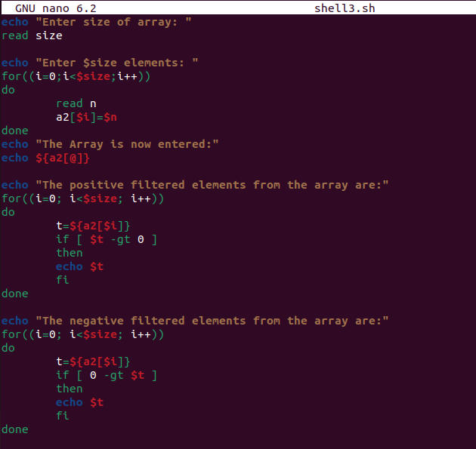

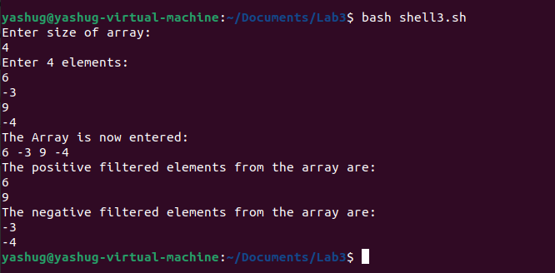

2.Write Shell script to find out even and odd numbers from accepted array.Assume Array

   consists of 5 numbers. Also accept arrays from users.

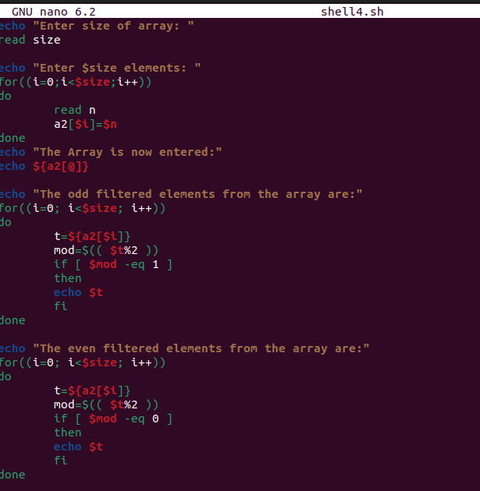

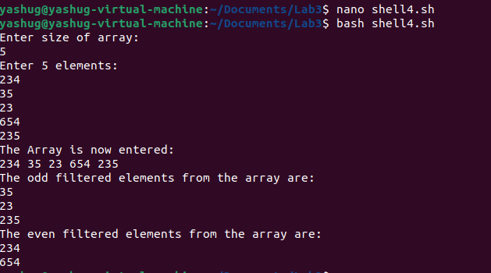

3.Write Shell script to sort array numbers ascending and descending order.Assume Array

   consists of 5 numbers. Also accept arrays from users.

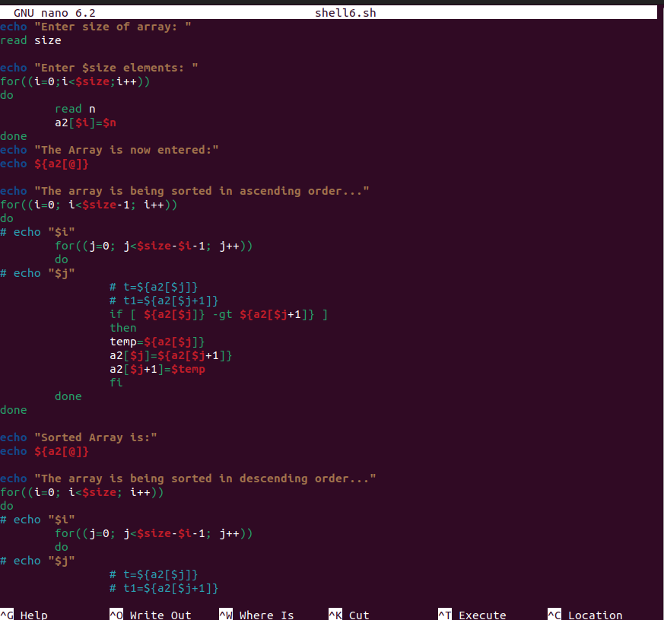

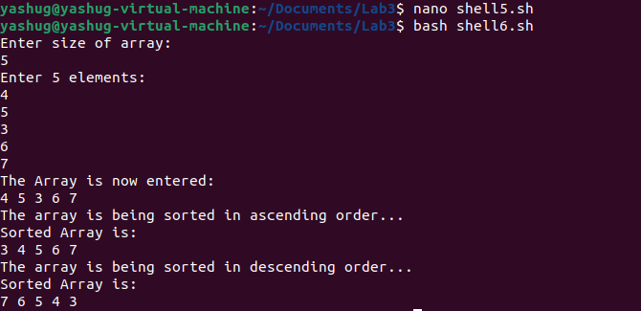

4.Write Shell script to find out smallest number and largest number of given array.Assume

   Array consists of 5 numbers. Also accept arrays from users.

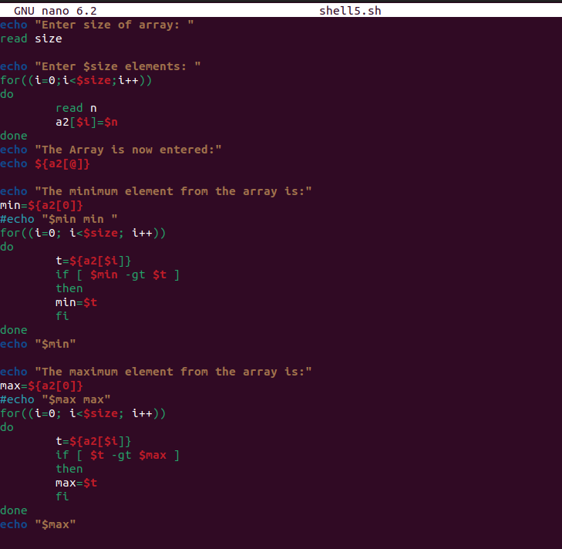

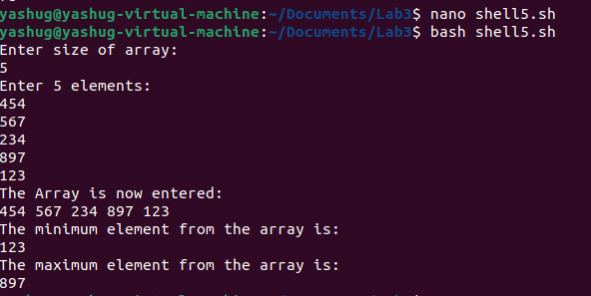

5.Write shell script to find out the reverse number of a given number.

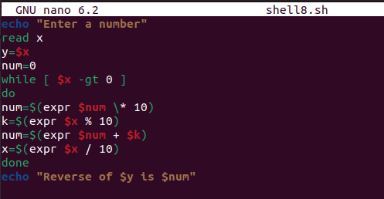

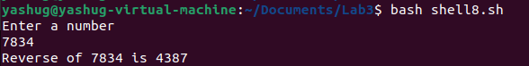

6.Write a shell script to create a fibonacci series.

